Parallel and Distributed Computing

CSE4001

Fall Semester 2020-21

Lab Assignment 1

**ISHAAN OHRI**

**18BCE0265**

**Aim:**

Write a simple OpenMP program to demonstrate the parallel loop construct.

1. Use OMP_SET_THREAD_NUM( ) and OMP_GET_THREAD_NUM( ) to find the number of processing unit
2. Use function invoke to print ‘Hello World’
3. To examine the above scenario, the functions such as omp_get_num_procs(),

omp_set_num_threads(), omp_get_num_threads(), omp_in_parallel(), omp_get_dynamic() and omp_get_nested() are listed and the explanation is given below to explore the concept practically.  
omp_set_num_threads() - takes an integer argument and requests that the Operating System provide that number of threads in subsequent parallel regions. omp_get_num_threads() (integer function) - returns the actual number of threads in the current team of threads.

omp_get_thread_num() (integer function) - returns the ID of a thread, where the ID ranges from 0 to the number of threads minus 1. The thread with the ID of 0 is the master thread.  
omp_get_num_procs() - returns the number of processors that are available when the function is called.

omp_get_dynamic() - returns a value that indicates if the number of threads available in subsequent parallel region can be adjusted by the run time. o omp_get_nested( ) returns a value that indicates if nested parallelism is enabled.

omp_set_num_threads() and omp_get_num_threads()

**Source Code:**

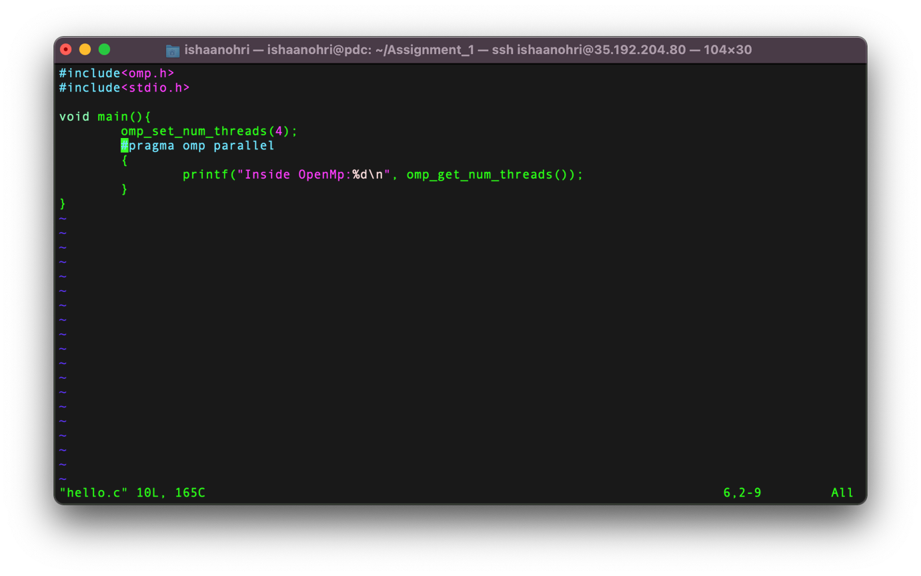

**Execution:**

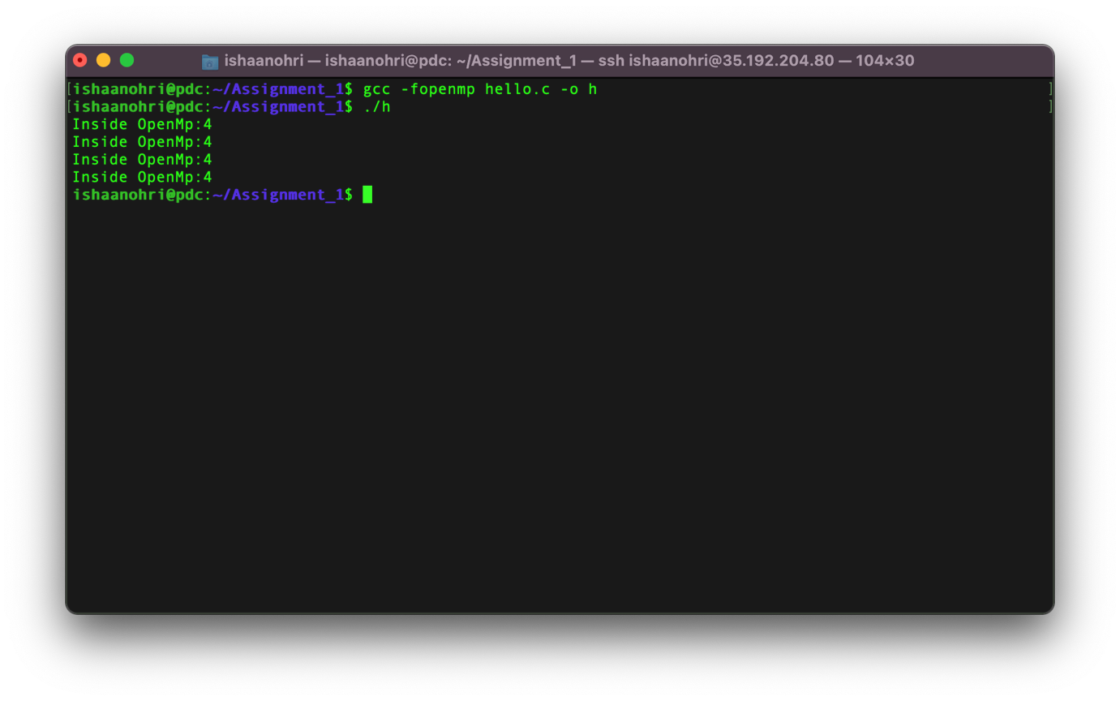

omp_set_num_threads() and omp_get_thread_num()

**Source Code:**

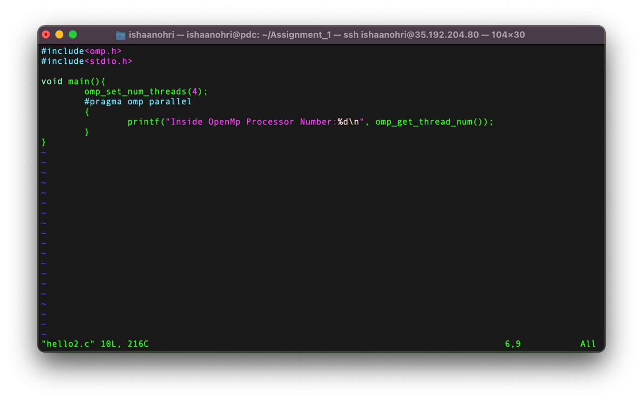

**Execution:**

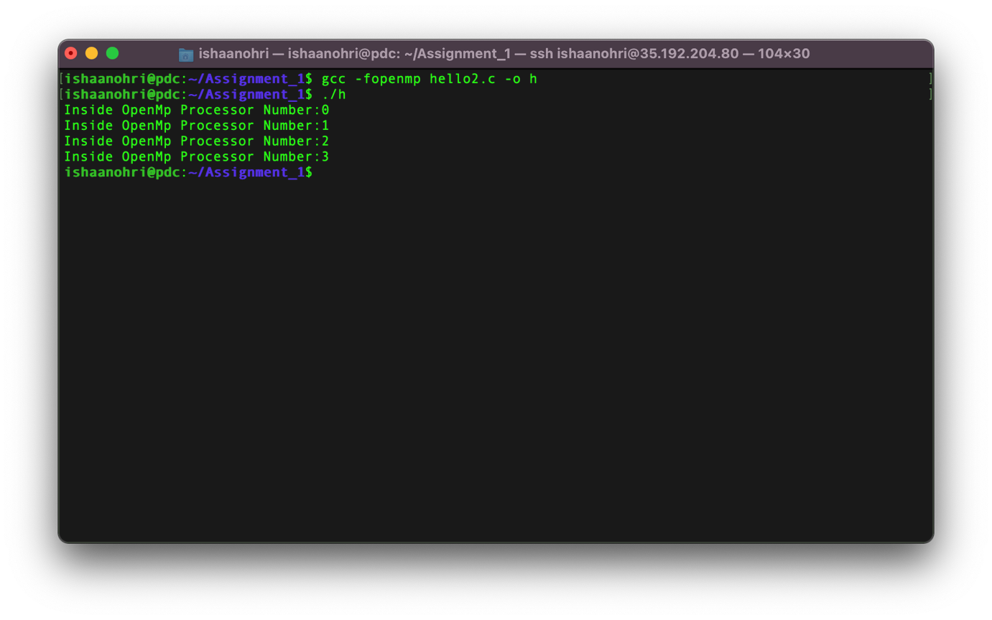

Invoking ‘Hello World’

**Source Code:**

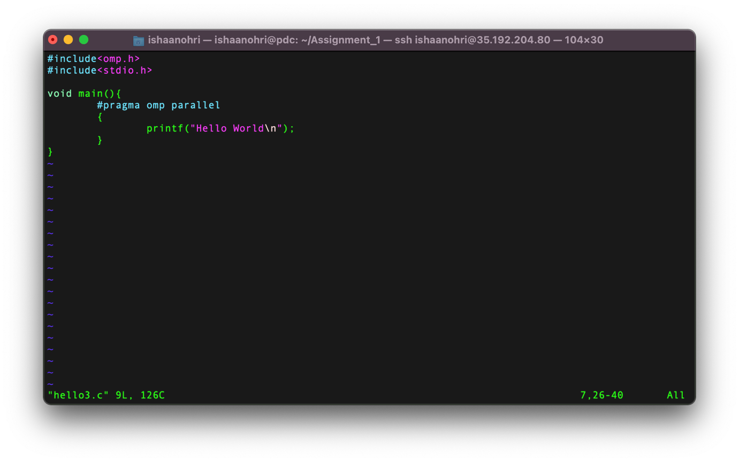

**Execution:**

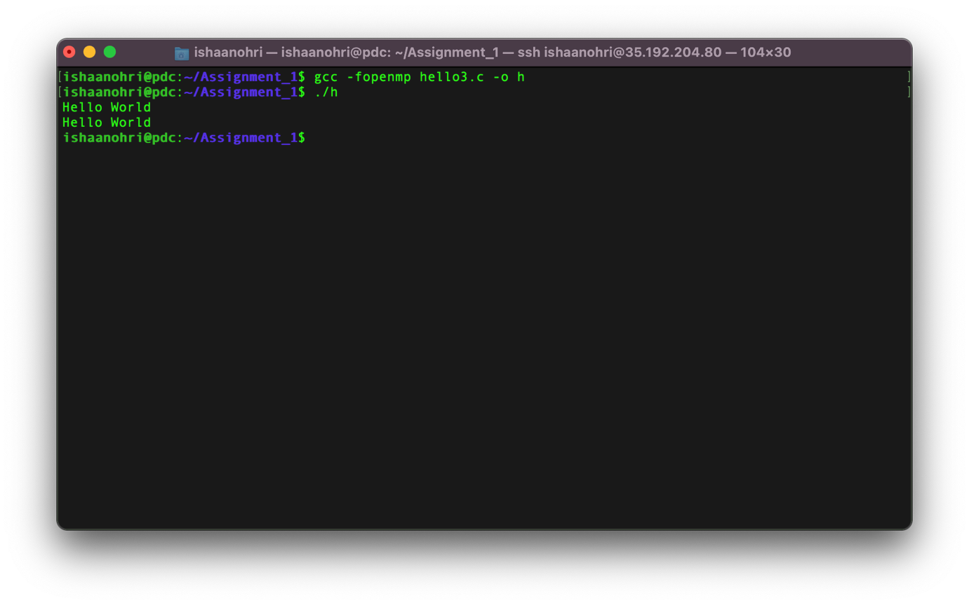

omp_get_dynamic()

**Source Code:**

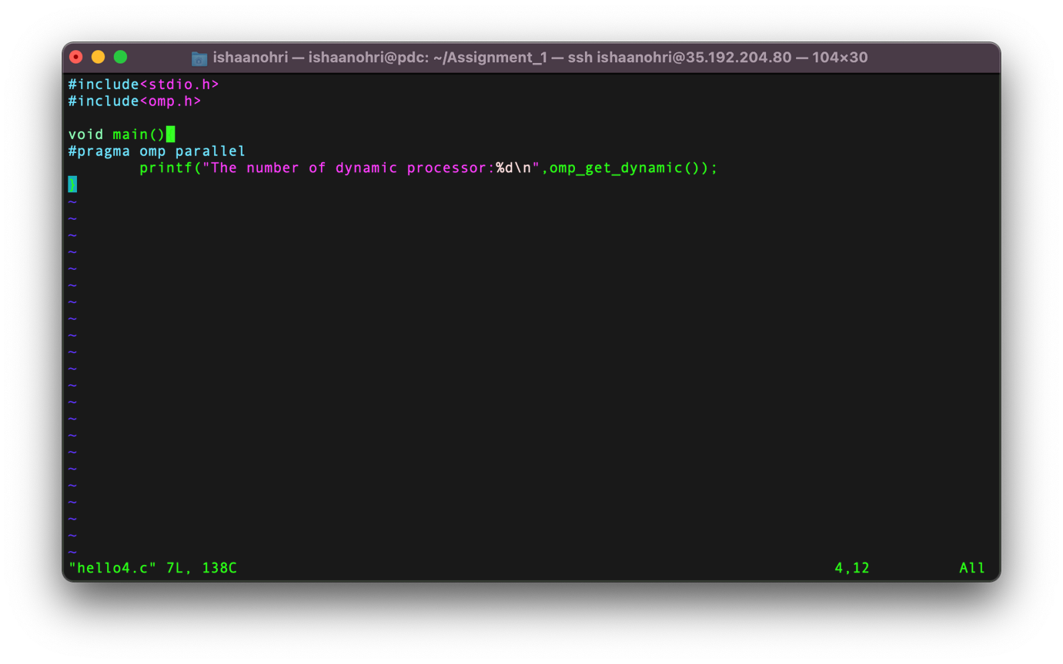

**Execution:**

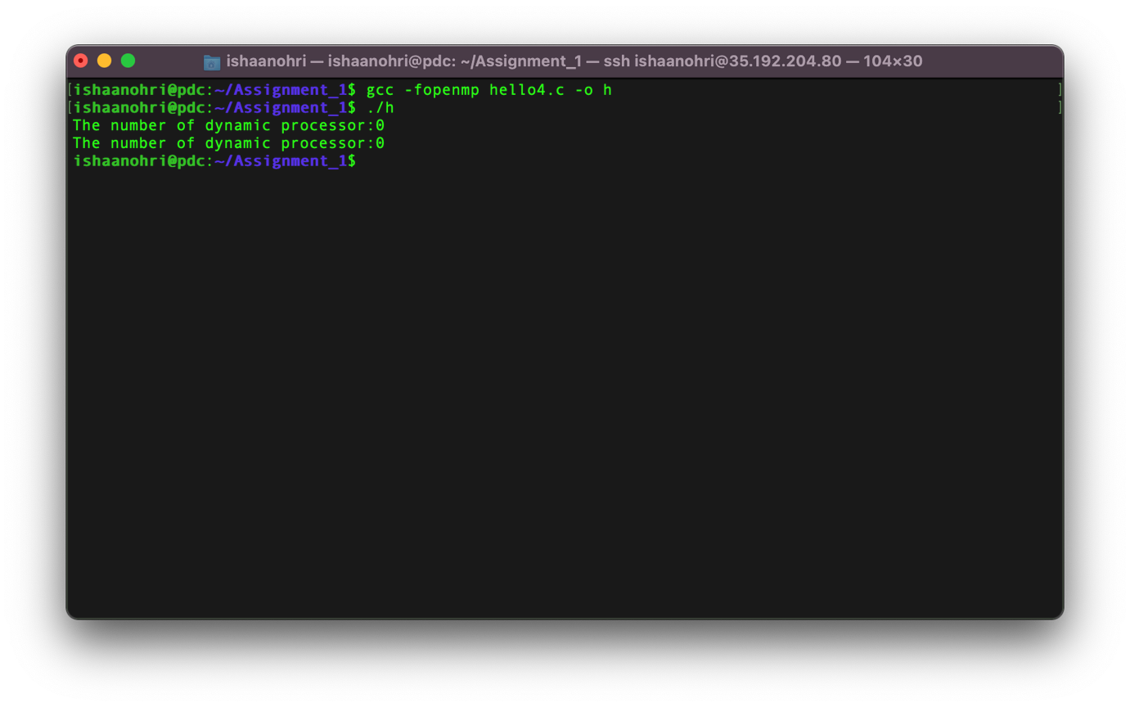

omp_get_nested()

**Source Code:**

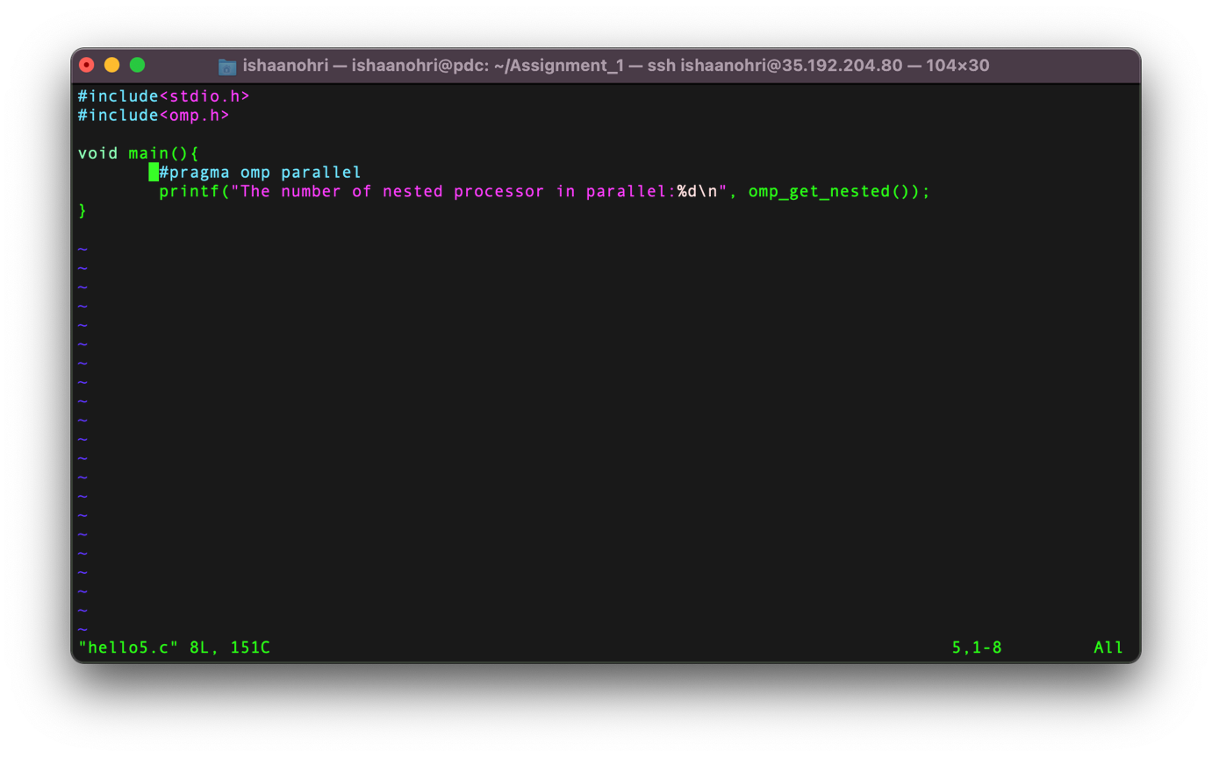

**Execution:**

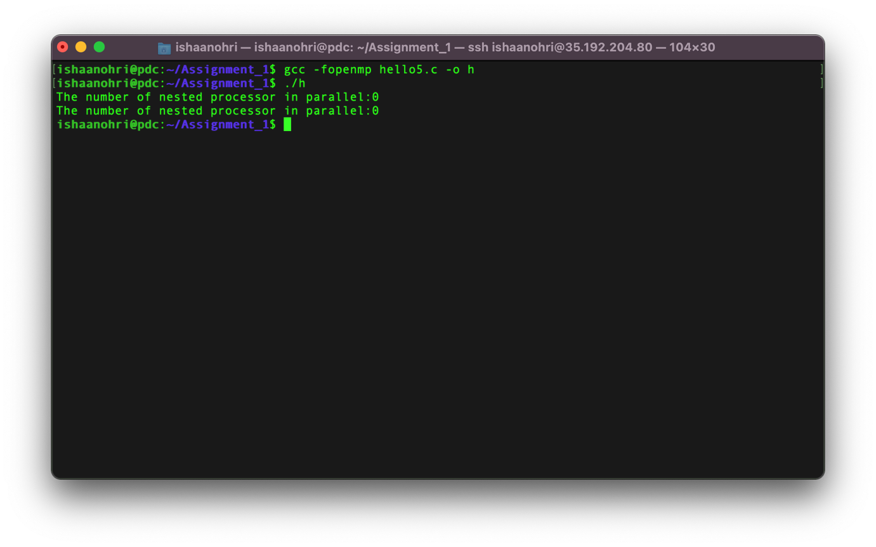

omp_get_num_procs()

**Source Code:**

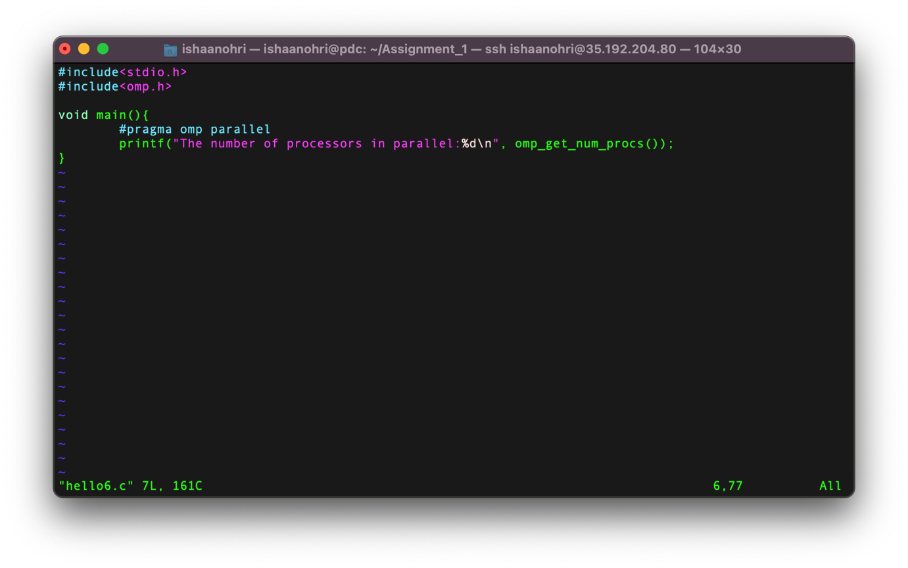

**Execution:**

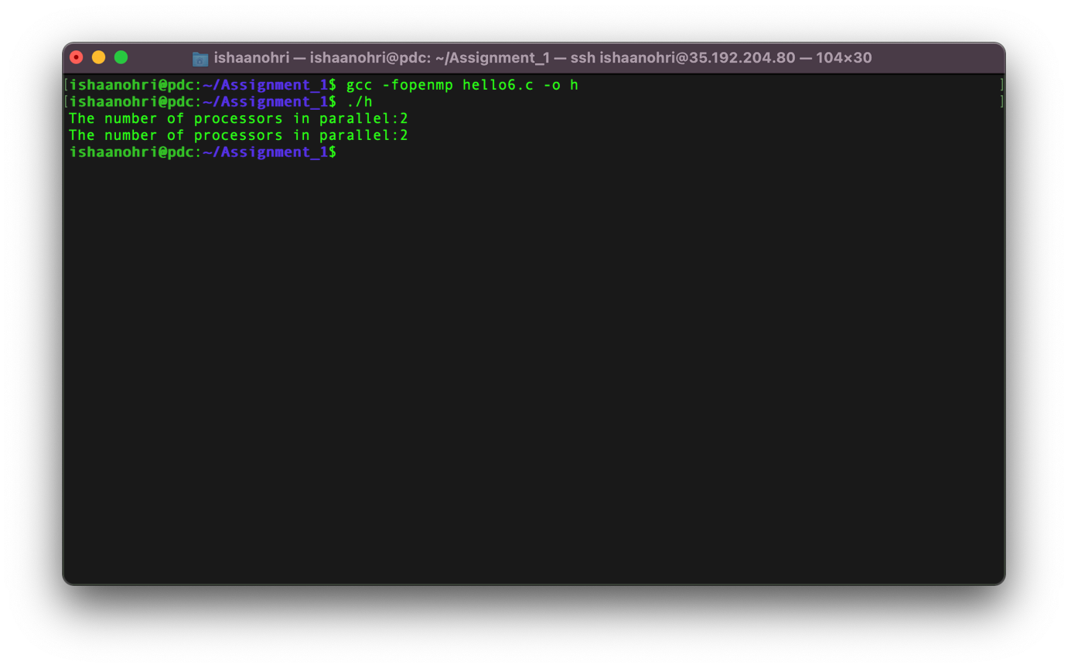

omp_in_parallel()

**Source Code:**

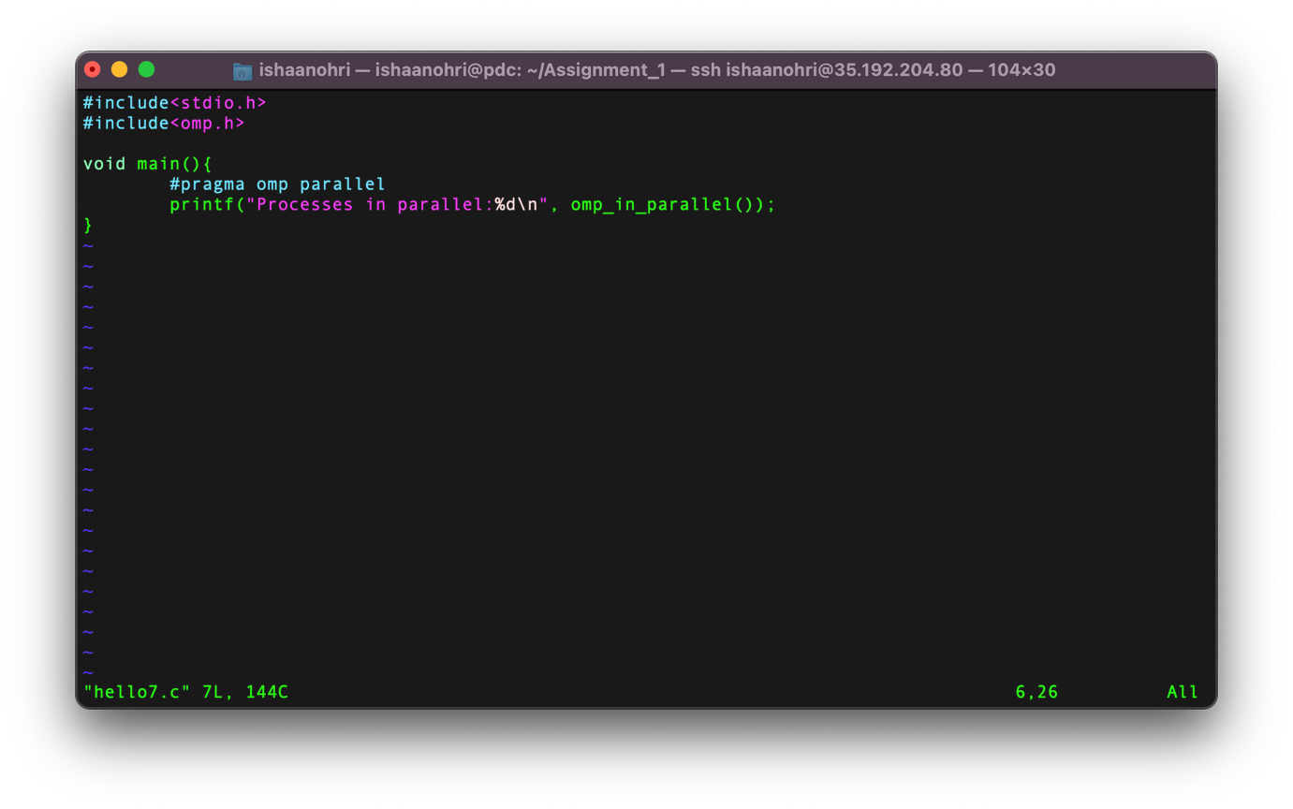

**Execution:**

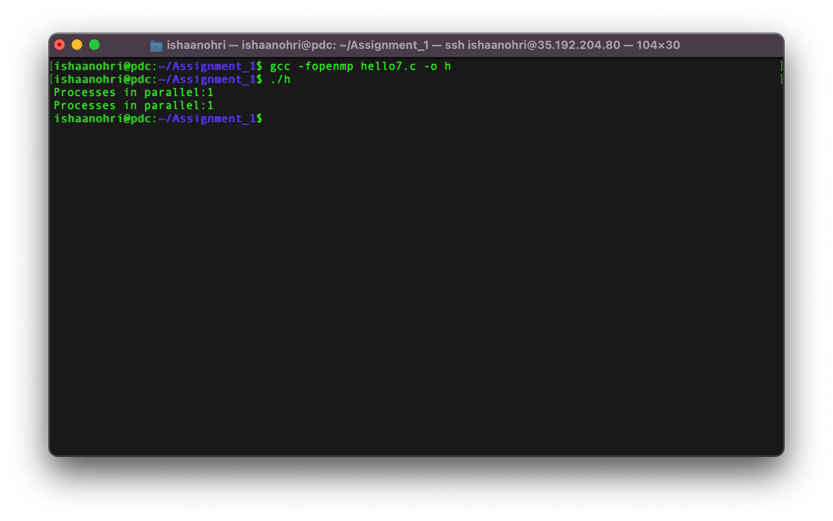

**Remarks:**

The above experiment was conducted and all results along with the source code have been attached above in the document. The experiment was assisted by Dr Deepak. I thank sir for his assistance.